Sign up on Supabase and Create DB Tables
Watch this video How to use Supabase for SQL.webm or follow the below steps.
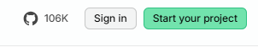
- Visit Supabase | The Open Source Firebase Alternative


- Select Sign in

- Then Sign up

- You can use personal or bootcamp email to sign up

- Check your inbox and confirm your email address

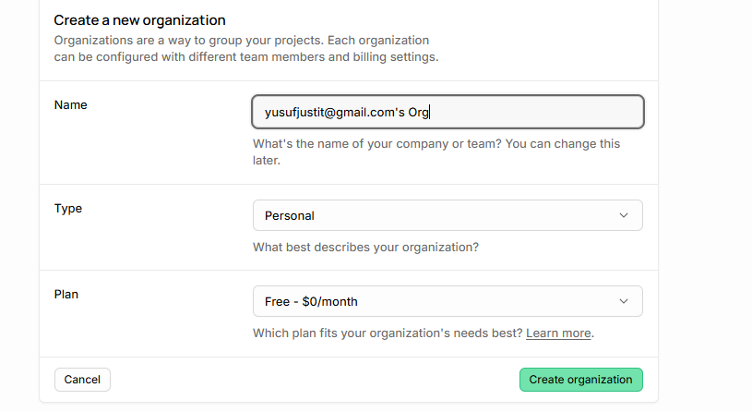
- Create new organization

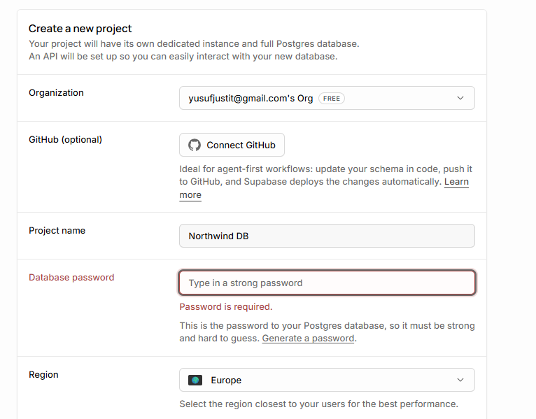
- Create a new project named Northwind and remember your password.

- Go to SQL editor
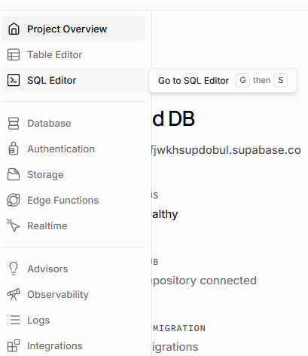

- Copy paste script from this file. Create tables supabase.docx or Create Tables Northwind.txt

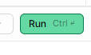
- Select Run to create tables.

- Run without RLS
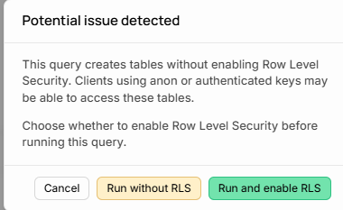
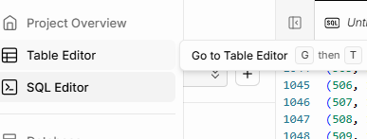
- Go to table editor and verify tables.

